**Stage 3 – Jack-O’-Lantern🎃**

**RULES:** USPSA Competition Rules, Latest Edition **COURSE DESIGNER:** Ike Starnes

|  |  |
| --- | --- |
| **START POSITION: See written stage briefing.** | |
| **STAGE PROCEDURE**  See written stage briefing. | **SCORING**  **SCORING:** Comstock 20 rounds.  **TARGETS:** There are 9 cardboard targets and 2 steel targets  **SCORED HITS:** 2 Best hits per carboard will be scored. Steel must fall to score.  **START-STOP:**  Audible - Last shot  **PENALTIES:** Per USPSA Competition Rules |

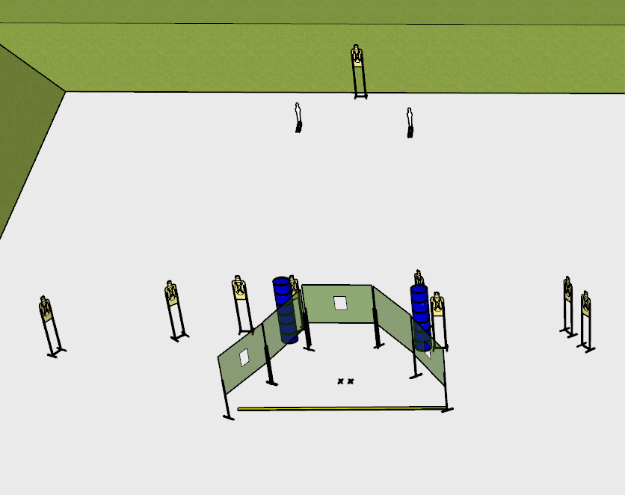

**Written Stage Briefing:**

**Stage 3 – Jack-O’-Lantern🎃 –** is a **20-round**, **100 point**, Comstock Medium Course. There are **9 cardboard** targets and **2 steel** targets. The best **2 hits** per cardboard target will be scored. The steel targets must fall to score.

**Start position** Facing directly downrange with both feet on the **Shooting Sports Innovations** Xs.

**Handgun** is **loaded** and holstered with wrists below belt.

**PCC** is **loaded**, with buttstock on belt, muzzle pointed at rear berm.

On the audible start signal, engage targets from within the shooting area.

**Setup Notes:**

Ensure no shoot through issues with targets from port to rear targets.

Ensure that the targets in the middle of the bay stapled high enough on the target sticks such that rounds do not impact the deck of the bay.

2 Single Wall Stands

4 Double Wall Stands

2 Solid Walls

3 Ported Walls

9 Target stands / 18 target sticks

4+ barrels

2 mini poppers / stands